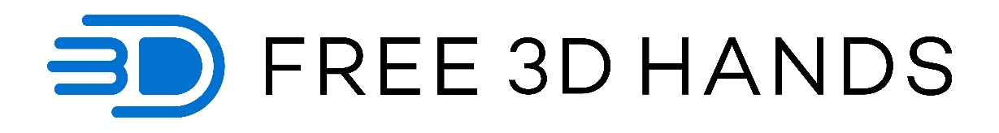
Mat Bowtell bio:
Mat Bowtell is the founder and CEO of Free 3D Hands, an Australian charity who designs and 3D prints hands and assistive devices. The hands are provided for free, to children and adults all around the world and they even pay the postage! Mat freely shares his designs under an open-source licence so others can make and repair their own devices and to encourage further innovation. Mat's goal is to significantly bring down the cost of assistive technology to help those who currently cannot access or afford it.

Free 3D Hands bio:
Free 3D Hands is an Australian charity who designs and 3D prints hands and assistive devices. The hands are provided for free, to children and adults all around the world and they even pay the postage! Founder and engineer Mat Bowtell freely shares his designs under an open-source licence so others can make and repair their own devices and to encourage further innovation. Mat's goal is to significantly bring down the cost of assistive technology to help those who currently cannot access or afford it.
Located on Phillip Island, the small team have provided hundreds of devices all around the world. Their designs are also being made by volunteers in Italy, Thailand, France, South Africa, Egypt, USA, Poland and others.
They are currently developing a low cost, multi-grip bionic arm and are making exciting progress with the latest prototype. Their goal is to make the equivalent of a $60,000 bionic arm...for under $60 in parts!
To learn more about Free 3D Hands or to make a donation, head to their website at http://www.free3dhands.org

